- How old are you?
  - I’m 30 years young.
  - I’m 30 years old.
  - I’m 30 years.
  - I’m 30.
*50% of your fellow classmates got this correct
- She travelled to France…
- with a car.
- by car.
- on a car.
- by a car.
*75% of your fellow classmates got this correct
- I have lived here…
- for three years.
- three years.
- since three years.
- three years ago.
*75% of your fellow classmates got this correct
- Would you please…
- make a photo for us?
- take a photo for us?
- do a photo for us?
*75% of your fellow classmates got this correct
- We…
- likes going to the movies.
- like to go to the movies.
- liked go to the movies.
- likes to go to the movies.
*50% of your fellow classmates got this correct
- Tomorrow, Daniel…
- will goes to New York.
- go to New York.
- is going to New York.
- will go to New York.
*75% of your fellow classmates got this correct
- Please have this document ready…
- until 5:00 p.m.
- by 5:00 p.m.
- up to 5:00 p.m.
- during 5:00 p.m.
*25% of your fellow classmates got this correct
- I usually teach English…
- by Tuesdays.
- Tuesdays.
- on Tuesdays.
- at Tuesdays.
*75% of your fellow classmates got this correct
- I would buy a big house if…
- I was rich.
- I would be rich.
- I am rich.
- I were rich.
*50% of your fellow classmates got this correct
- Last night, I went to a…
- fun party.
- funny party.
*25% of your fellow classmates got this correct
- Before you leave, please…
- turn the lights off.
- put the lights off.
- do the lights off.
- make the lights off.
*75% of your fellow classmates got this correct
- I’m bored, has the teacher arrived…
- still?
- yet?
- now?
- already?
*75% of your fellow classmates got this correct
- This is the girl ...
- she I met last Thursday.
- which I met last Thursday.
- what I met last Thursday.
- I met last Thursday.
*75% of your fellow classmates got this correct
- The marathon is tomorrow, so I…
- expect it’s not going to rain.
- hope it’s not going to rain.
- think it’s not going to rain.
- wish it’s not going to rain.
*75% of your fellow classmates got this correct
- Adjective order
- That's a little old red house.
- That’s a red little old house.
- That’s a red old little house.
- That’s an old red little house.
*0% of your fellow classmates got this correct
- I won’t go to the doctor’s office…
- except you come with me.
- otherwise you come with me.
- outside you come with me.
- unless you come with me.
*75% of your fellow classmates got this correct
- Where is the animal in relation to the box?
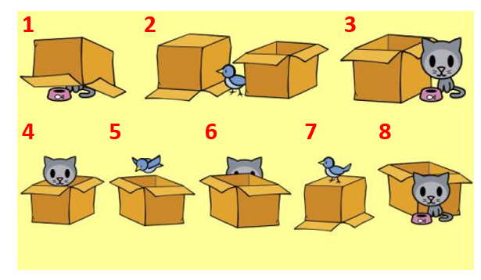

1. under, underneath
67% of your fellow classmates got this correct
2. between, among
67% of your fellow classmates got this correct
3. near, next to, to the right of, on the right of, by
67% of your fellow classmates got this correct
4. inside of, in
67% of your fellow classmates got this correct
5. above, flying over
67% of your fellow classmates got this correct
6. behind
67% of your fellow classmates got this correct
7. on top of, on
0% of your fellow classmates got this correct
8. in front of
67% of your fellow classmates got this correct

